**Review Worksheet Answers Cultural Evolution**

1: Write yes or no to indicate which of the following cultural practices were known to occur with each of the Hominin species:

(1 mark for each fully correct row – 9 marks)

|  |  |  |  |  |  |
| --- | --- | --- | --- | --- | --- |
|  | ***Australopithecus*** | ***Homo habilis*** | ***Homo erectus*** | ***Homo neanderthalensis*** | ***Homo sapiens*** |
| Made and Used tools | *Yes?* | *Yes* | *Yes* | *Yes* | *Yes* |
| Built shelters | *No* | *No* | *Yes* | *Yes* | *Yes* |
| Made and used fire | *No* | *No* | *Yes* | *Yes* | *Yes* |
| Ate meat | *No* | *Yes* | *Yes* | *Yes* | *Yes* |
| Complex language | *No* | *No* | *Yes?* | *Yes* | *Yes* |
| Wore clothing | *No* | *No* | *No* | *Yes* | *Yes* |
| Buried their dead | *No* | *No* | *No* | *Yes* | *Yes* |
| Made art | *No* | *No* | *No* | *No* | *Yes* |
| Symbolic thought | *No* | *No* | *No* | *No* | *Yes* |

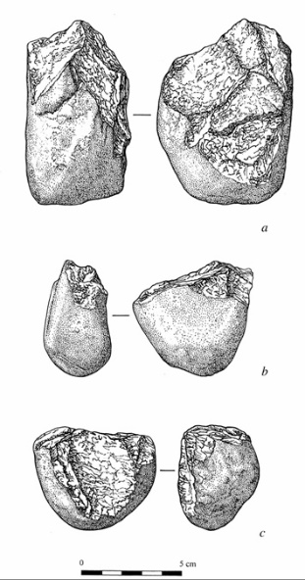2: Name the following tool types and which species made them.

(6 marks)

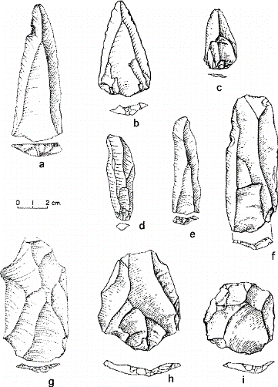

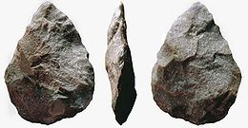

|  |  |  |
| --- | --- | --- |
| *Acheulean Hand Axe* | *Mousterian Tools* | *Oldowan Tools* |
| *Homo erectus* | *Homo neanderthalensis* | *Homo habilis and maybe Australopithecus* |

3: Describe trends seen in tool culture between *Australopithecus* and *Homo sapiens.*

(3 marks)

*Over time:*

* *tools move from generalised shapes and uses to specialised shapes and uses*
* *tools move from coarse flaking to fine flaking and shaping*
* *tools move from single materials (stone) to varied materials (stone, wood, bone, antler…)*

4: a) For each of the tools below, decide which *Homo sapiens* Cro Magnon tool culture (that we

have learned about in class) they belong to, and give reasons for your answer.

(9 marks)

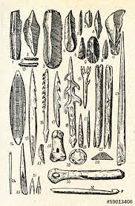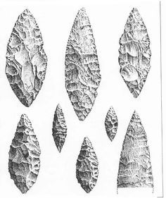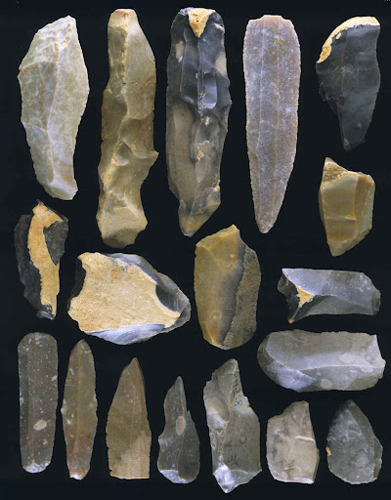

|  |  |  |
| --- | --- | --- |
| *Aurignacian* | *Magdelanian* | *Solutrean* |
| *Tools made of stone*  *Predominantly blade tools* | *Wide variety of specialised tool types*  *Variety of materials – stone, bone, antler* | *Very fine pressure flaking*  *Leaf shaped blade* |

b) Name which of the tool cultures above is the oldest, and which is the most recent.

(1 mark)

*Aurignacian is the oldest, Magdelanian is most recent.*

5: What was the Neolithic revolution and why was it important?

(4 marks)

*The Neolithic revolution was when Homo sapiens first began to live in settlements (1), and to domesticate plants and animals (1). It was important because staying in one place and growing plants and livestock meant energy/survival needs were met more easily (1), and people had more time free to think, plan and innovate (1).*

6: Describe the steps of inflammation in detail, from the moment of tissue injury until the stage is set for tissue healing.

(11 marks)

*A: Tissue damage occurs (0.5). Pathogens may or may not be introduced and continue damage (0.5)*

*B: Tissue damage (0.5) causes Mast Cells (0.5) to release Histamine (0.5) and Heparin (0.5)*

*Histamine causes local capillaries (0.5) to dilate and become leaky (0.5), to allow leukocytes to enter the area of tissue damage (0.5). This causes redness, heat, swelling and pain. (0.5)*

*Heparin prevents clotting in the immediate area. (0.5)*

*C: Complement proteins (0.5) are activated (0.5) and attract phagocytes (0.5), which are able to enter the tissues due to the leaky, dilated vessels in the area (0.5). The phagocytes engulf and digest dead cells and bacteria. (0.5)*

*D: Once pathogens are cleared (0.5), mast cells and complement (0.5) cease chemical messaging (0.5). Local capillaries return to normal (0.5), phagocytosis stops (0.5) and the stage is set for tissue healing (0.5).*